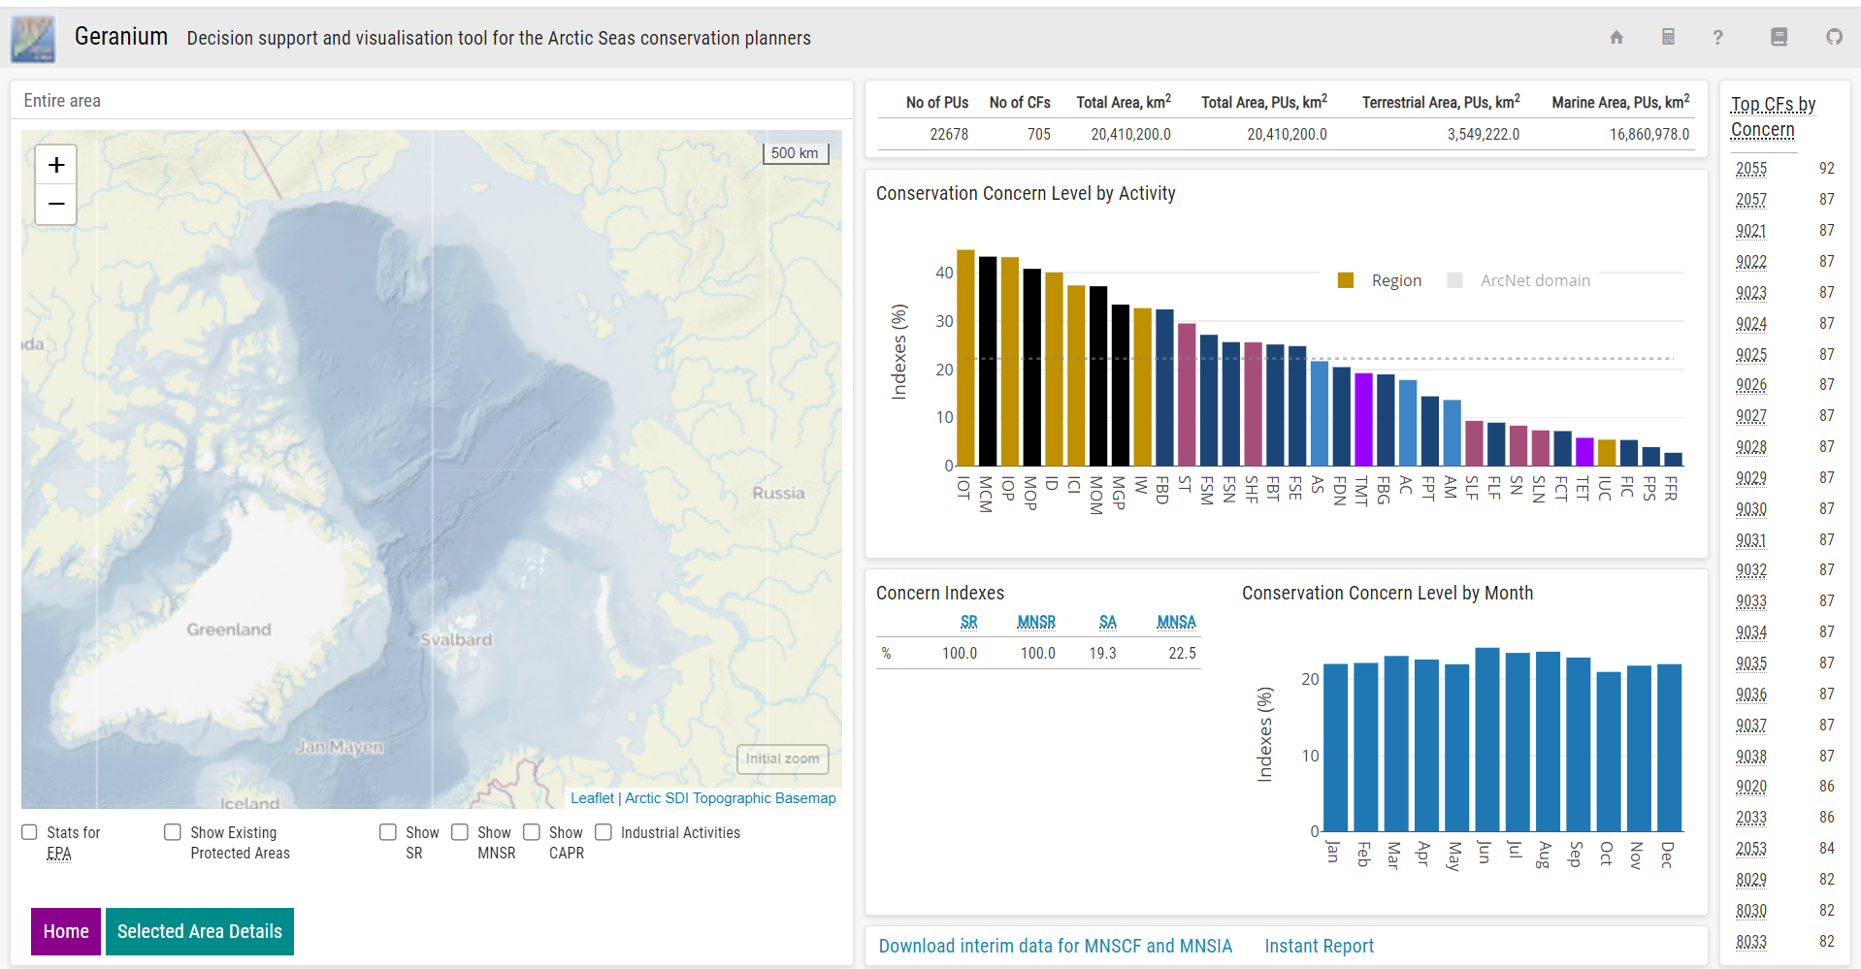

**13**

**12**

**11**

**10**

**9**

**8**

**7**

**6**

**5**

**4**

**3**

**2**

**1**

1 – заменить “Region” на “AOI”

2 - заменить "Indexes” на “%”

3 – заменить “SR” на “RSC-PU”

4- заменить “MNSR” на “ROC-PU”

5 - заменить "SA” на “RSC-AOI”

6-заменить “MNSA” на “ROC-AOI”

7-заменить "Conservation concern level by activity” на “Relative Overall Concern Level by Activity (ROC-IA)” и для графика по месяцам “Conservation Concern Level by month” на “Relative Overall Concern Level by Month (ROC-M)”

8- заменить “Indexes” на “%”

9- “Download assessment results for OC-CF and OC-IA”

10- заменить “Show CAPR” на “Show OIP-P”

11 - заменить "Show MNSR” на “Show OC-P”

12- заменить “Show SR” на “Show SC-P”

13- заменить "Entire area” на “ArcNet domain”

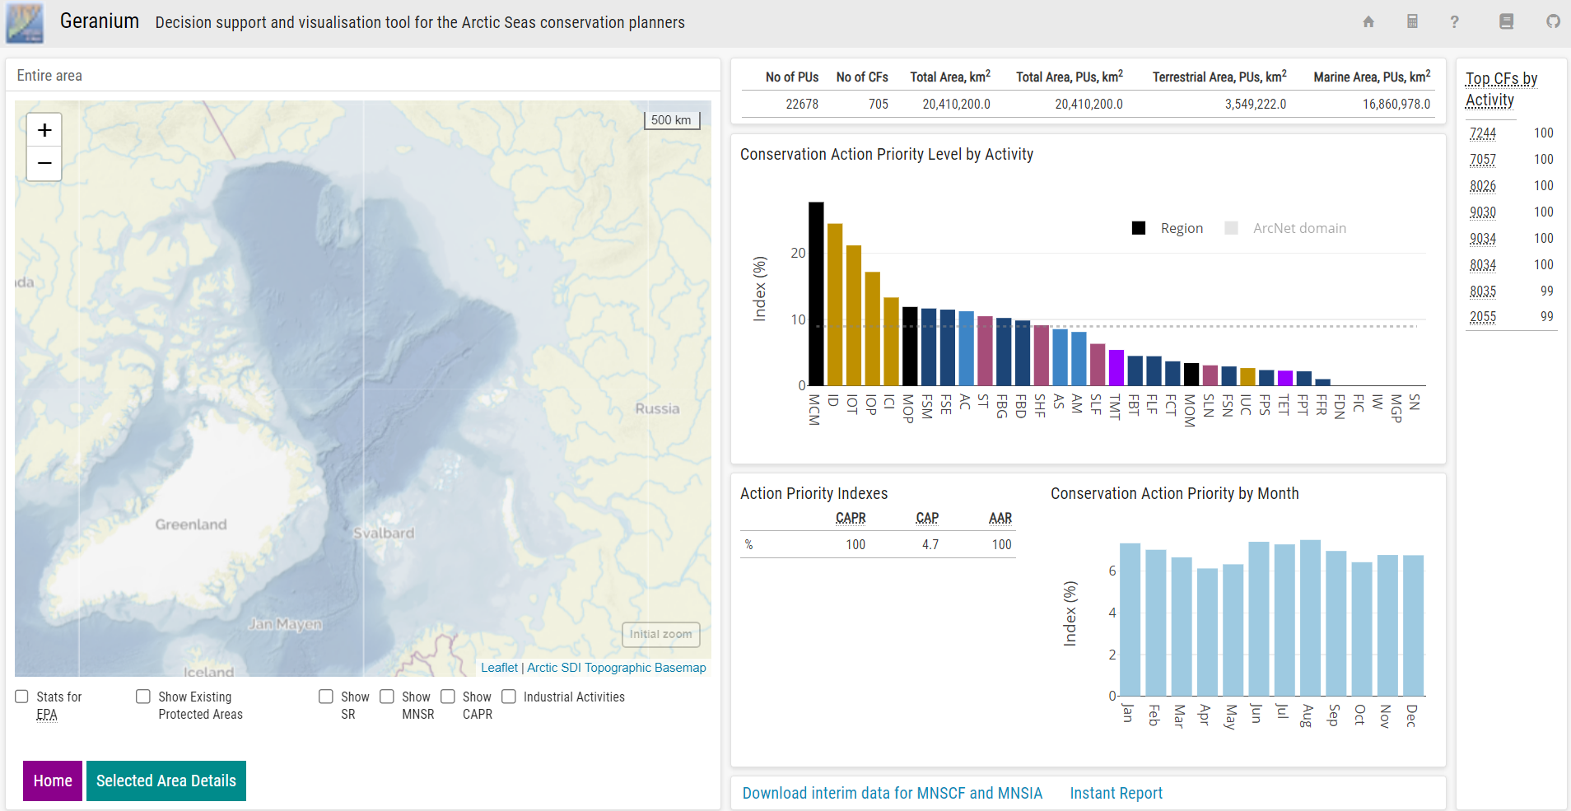

**12**

**10**

**11**

**9**

**8**

**5**

**4**

**3**

**2**

**1**

**7**

**13**

1 – Replace “Region” for “AOI”

2 - Replace "Indexes” for “%”

3 – Replace "CAPR” for “OIP-P”

4- Replace “CAP” for “OIP-AOI”

5- Replace "AAR” for “AA-PU”

7 - Replace "Conservation Action Priority Level by Activity” for “Overall Industrial Pressure by Activity (OIP-IA)” и для графика по месяцам на “Overall Industrial Pressure by Month (OIP-M)”

8- Replace “Indexes” for “%”

9- “Download assessment results for OC-CF and OC-IA”

10- Replace “Show CAPR” for “Show OIP-P”

11 - Replace "Show MNSR” for “Show OC-P”

12- Replace “Show SR” for “Show SC-P”

13- Replace "Entire area” for “ArcNet domain”

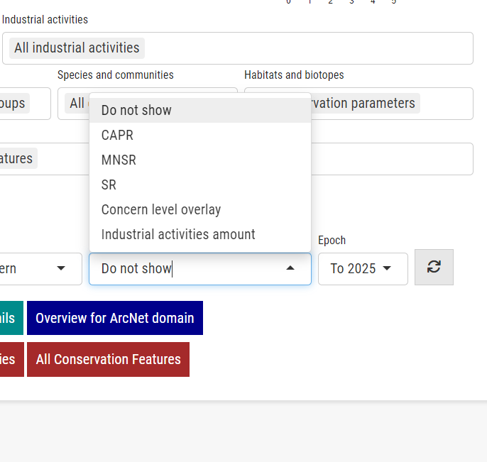

**3**

**2**

**1**

1 – OIP-P

2 – OC-P

3 -SC-P

Заменить “domain” на название индекса, для которого выводится карта: в случае OIP-P – OIP-P, для OC-P – OC-P, для SC-P – SC-P, для Industrial Activities amount - Amount.